Pokhara University

Level: Bachelor | Semester – Spring | Year : 2005
Programme: BE |  | Full Marks: 100
Course: Image Processing and Pattern Recognition |  | Time : 3hrs.

Candidates are required to give their answers in their own words as far as practicable.
The figures in the margin indicate full marks.

Attempt all the questions.

 | - Mention various zooming techniques with their merits and demerits. A 3×3 size image has following intensity information  1 7 6  4 6 2  1 5 3  Change this image into 6×6 size image using replica method.  - Explain digital image processing system with neat diagram. | 7  8
 | - Find the Fourier spectrum of the function shown below.  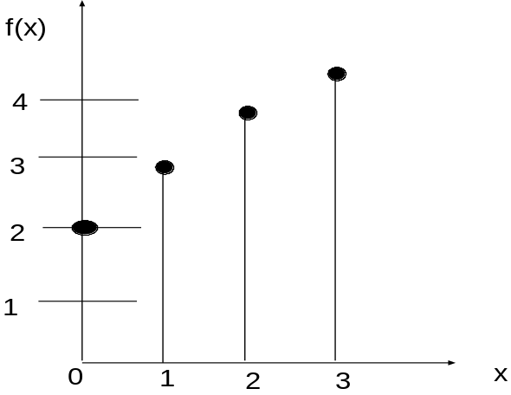 | 8
 | - Define Discrete Cosine Transform. Mention the properties and its role in digital image processing. | 7
 | - Compute the histogram of equalization of the data given below.  - Explain Lossy predictive coding with example. | 8  7
  r_{k} | 0 | 1 | 2 | 3 | 4 | 5 | 6 | 7
  n_{k} | 5320 | 1000 | 500 | 525 | 1236 | 956 | 856 | 128
 | - Given the following frequency table obtained from the histogram of a 64×64, 8 level image.  Where r = gray level and n_{k} = pixel having r^{th} gray level  Construct Huffman code for each gray level.  - Mention the role of feature extraction in digital image processing. Explain in brief some techniques for feature extraction. | 8  7
  r | 0 | 1 | 2 | 3 | 4 | 5 | 6 | 7
  n_{k} | 400 | 1350 | 639 | 2054 | 816 | 2500 | 550 | 1500
 | - How template matching recognize the presence of object class in image. Explain.  - What is segmentation? How do you select the threshold in segmentation by thresholding technique? Explain any one technique. | 8  7
 | - What is neural network? Explain Hamming network.  - What is Hough transform? How it is useful in line detection. | 8  7
 | Write short notes on (Any Two):  - Edge detection  - Bit Plane Coding  - Image averaging | 2x5

